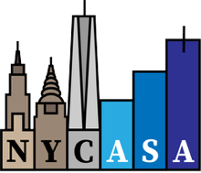 Sponsorship Packages

The 2nd Artificial Intelligence (AI) Workshop New York City (NYC)

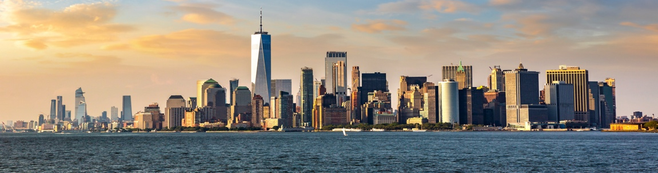

Organized by the American Statistical Association (ASA) NYC Chapter and AI4Purpose

Event Overview

- The Second AI Workshop NYC, themed AI and Statistics Intersect, brings together statisticians, AI researchers, data scientists, policymakers, and mission-driven organizations to explore how artificial intelligence can be used responsibly for societal benefit.

- Venue: Regeneron, Sleep Hollow (Pending Confirmation)
- Dates: Saturday, July 25 or Sunday, July 26, 2026
- Sample 2025 Website: https://ai4purpose.com/innovate/think-tank/ai-workshop-nyc-july-20-2025
- Attendance: 125+
- Organizers: Nonprofit Charitable Companies 501(c)(3)
  - EINs are provided upon request after sponsorship confirmation
- Contact: NYCASAChapter@gmail.com, cc’ing AI4Purpose@gmail.com

Participants:
  - Statisticians & quantitative researchers
  - AI scientists and modelers
  - Academic and industry statisticians
  - High school to graduate students
  - Hackathon contestants (university and high-school tracks)

Rational for Sponsorships:
- Align with ethical, responsible AI
- Reach a highly technical, influential audience
- Support education and statistics/data science in AI
- Build relationships across academia and industry (e.g., healthcare, finance, IT, etc.)

Sponsors receive exposure through:
- Amstat News, Official Magazine of the ASA
  - https://magazine.amstat.org/blog/2025/10/01/ai-workshop
- Social media campaigns, LinkedIn and X
- Event website & registration portal
- On-site signage and digital logo display

Sponsorship Options (in USD)

(A) Multiple Sponsorships:

Platinum — $10,000
- Premier logo placement on all materials
- 6 complimentary registrations
- 1 live demo and 1 expert panel session
- Prime exhibitor table
- Branded swags
- Social media spotlight
- Post-event analytics recap in Amstat News

Gold — $7,500
- Logo placement on website, signage, and program
- 4 complimentary registrations
- 1 live demo session
- Exhibitor table
- Branded swags
- Social media spotlight
- Post-event analytics recap in Amstat News

Silver — $5,000
- Logo placement on website and signage, and program
- 2 complimentary registrations
- 1 expert panel session
- Exhibition table
- Branded swags
- Recognition during opening & closing

Bronze Sponsor — $2,500
- Logo placement on website and signage, and program
- 1 complimentary registration
- Exhibition table
- Branded swags
- Recognition during opening & closing

(B) Single Sponsorships

Note: Pricing based on estimated attendance of 125 participants.

Check-In — $625 ($5 per person)
- Logo on badge
- Lanyard

Morning or Afternoon Coffee — $1,250 ($10 per person)
- Logo at stations
- Verbal recognition before break

Morning or Afternoon Snacks — $1,250 ($10 per person)
- Logo at stations
- Verbal recognition before break

Breakfast — $5,000 ($40 per person x 125 attendees)
- Logo on breakfast signage
- Recognition during breakfast

Lunch — $5,000 ($40 per person x 125 attendees)
- Logo on lunch signage
- Recognition during lunch

Reception — $5,000 ($40 per person)
- Logo on reception signage
- Recognition during reception

(C) Award Sponsorships

Student Hackathon Award, High-School Track — $1,500 ($1,000 1st Prize, $300 2nd Prize; $200 3rd Prize)
- Logo on award certificates
- Verbal recognition

Student Hackathon Award, University Track — $1,500 ($1,000 1st Prize, $300 2nd Prize; $200 3rd Prize)
- Logo on award certificates
- Verbal recognition

Student Hackathon Award, Professional Track — $1,500 ($1,000 1st Prize, $300 2nd Prize; $200 3rd Prize)
- Logo on award certificates
- Verbal recognition

Note: If insufficient contestants per track, prizes may be combined or rolled over to other categories or the 2027 Workshop.

Trivia Sponsor — $500 (AMEX Gift Card at $25 x 20 awards)
- Verbal recognition

Note: All Sponsorships are tax-deductible to the extent permitted by the New York State and US Laws. No goods or services are exchanged beyond recognition benefits listed.
